File Name: mux.vhd
Program 1: Design and Implementation of a 4-to-1 Multiplexer Using VHDL
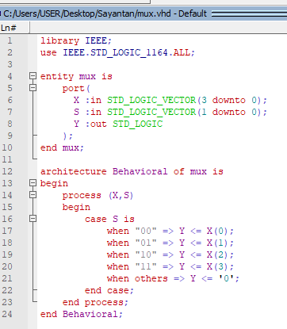
File Name: mux_8-1.vhd
Program 2: Design and Implementation of an 8-to-1 Multiplexer Using VHDL
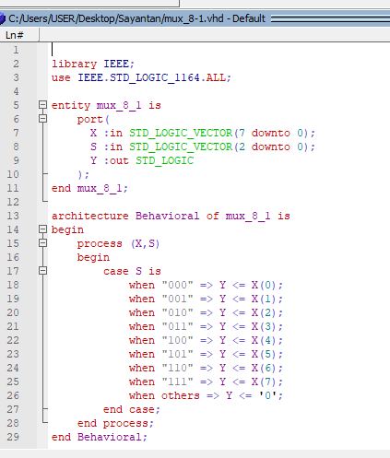
File Name: demux.vhd
Program 3: Design and Implementation of a 1-to-4 Demultiplexer Using VHDL
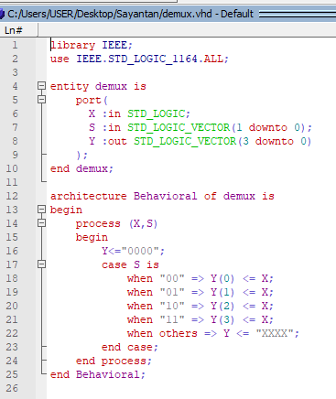
File Name: demux_1-8.vhd
Program 4: Design and Implementation of a 1-to-8 Demultiplexer Using VHDL
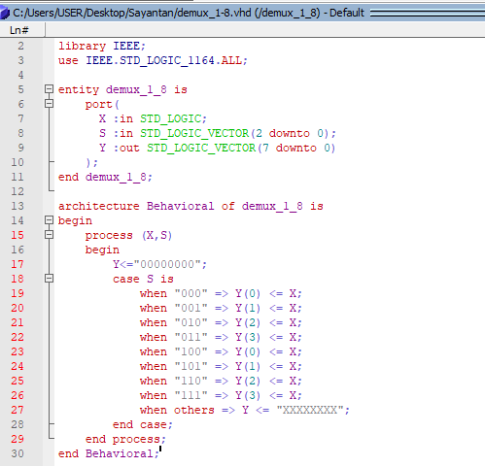
Figure 1: Simulated Waveform of a 4-to-1 Multiplexer
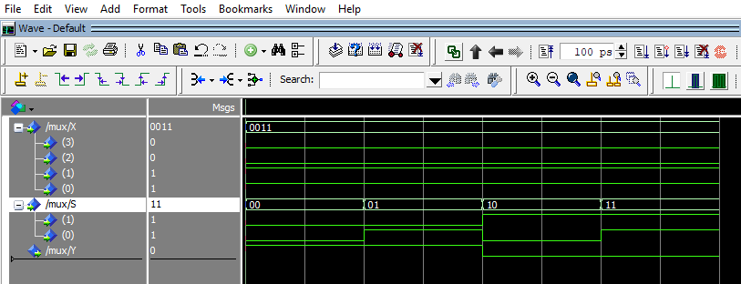
Figure 2: Simulated Waveform of an 8-to-1 Multiplexer
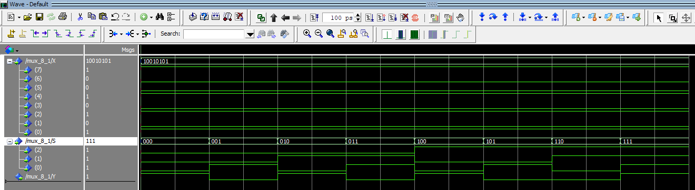
Figure 3: Simulated Waveform of a 1-to-4 Demultiplexer
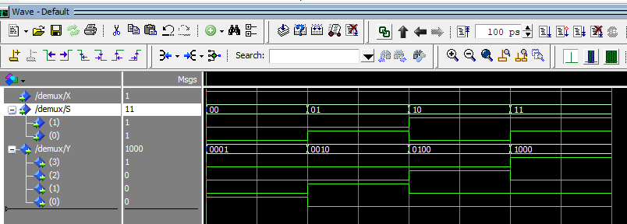
Figure 4: Simulated Waveform of a 1-to-8 Demultiplexer
